Campus Connect

Zoe mulhall-Brennan, Olena khyzhniak, Rayan Kortikela

2nd Year

2025

Contents

0

Overall Introduction to Project 2

Product Vision 2

Features 3

Personas 6

What is a Persona? 6

Persona 1 6

Persona 2 7

Persona 3 7

Persona 4 8

Scenarios 9

What is a Scenario? 9

Scenario 1 9

Scenario 2 10

Scenario 3 10

Scenario 4 11

User Stories 12

What is a User Story? 12

User Story 1 12

User Story 2 12

User Story 3 12

User Story 4 13

User Story 5 13

User Story 6 13

Revised Features 14

Prototype 18

What is a Prototype? 18

Tool used to create Prototype (say if you found it easy to use or not briefly!!!) 19

Diagrams 20

Java 24

# Overall Introduction to Project

## Product Vision

**For** – Students and Lecturers

**Who** – Students can have extra classes if needed. Our application is for friendly study meet ups between students preparing for the same exams and offers a variety of different notes that either students or lecturers want to add to it.

**Product Name and Category** – the product name is “Campus Connect”. This is a category of Educational Technology (EdTech) or Educational Services.

**That** – Helps students to improve their grades along with multiple skills such as communication, organizational and effective study skills.

**Unlike** – this product differs from platforms such as Google Classroom that is a way for students to upload work and get notes and assignments from lecturers. It also gives you reminders while campus connect, allows for accessing notes that other students took and lecturers notes. You can book tutor sessions or simply find people who are preparing for the same exams and meet up to study more effectively. This app also differs from ordinary tutor meet ups as they are not cost heavy, our tutoring sessions can be free or for donations to make it more efficient for students.

**Our Product** – our product offers not only tutoring sessions but also a platform to share notes, organise study meet ups and tutoring sessions with a range of pricing that suits all students.

# Features

**Description:**

Our app contains many features related to students in need for tutoring or exam study with peers such as:

* As a student I may find Study Meetups with others that need to study in groups or individually with the mentor/tutor.
* Search Bar:
* Search icon
* Search Button
* Label for search
* Textfield for searching
* List view to view the people looking to study the same exam as you
* Button to add a person studying for the same exam as a friend
* Scroll bar
* Join button to join a group session if one comes up in the list view
* Image view to see peoples profile pictures
* Label for title of list view
* Button to view profile
* As a lecturer or peer, I may create Tutor Meetups that are free, or donation based.
* Create button
* Delete Button
* Reset Button
* Text field for name
* Label for name
* Text field for subject
* Label for subject
* Date picker for availability
* Label for date availability
* Choice box for time availability
* Label for time availability
* Check box for individual or group
* Label for group or individual
* Image view for profile picture
* Label for profile picture
* Label for the title of the page
* As a student I can upload Images/Files of Notes to share with the groups or individuals.
* Image view (Multiple)
* Label for upload image
* Button for upload
* Button for deleting
* Button for resetting
* Text field for subject
* Label for subject
* Label for share to
* Choice box for share to
* A text field for who uploaded
* A label for uploaded by
* As user I want to add Comments to Notes.
* Text field to type out comment
* Add comment button
* Delete comment button
* List view to view other people’s comments
* As a user I may Rate a peer/tutor/meetups.
* A 5-star button that displays each user's personal experience with a peer/tutor/meetups
* Submit button
* As a student or lecture I want to create Schedules for meet ups.
* Date Picker that helps students keep track of their daily tasks/meetups/uploading notes
* Choice box for Times
* Text Field for description
* Save button
* List of upcoming meetups
* As a student or lecture I need Notifications to remind me of deadlines, meetups, new notes being uploaded.
* Allow and Decline Notifications button
* As a student/lecture/peer/tutor I want to create a Chat with the group or individuals.
* Choice Box to select a group
* “Search” bar to find a member
* Text field to type the message you want to send
* “Send” button to send a message
* As a student or lecturer, I may friend my peers/tutors/lecturers.
* “Search” bar to find users
* List of friends
* Accept/Decline button for incoming requests

**Constraints:**

* All users must have SETU ID. They may link their account with the Google account.

**Comments:**

* Payment system is needed.

# Personas

## What is a Persona?

A persona is a simple made-up character that represents a group of people to better understand the goals for the app to make sure the app will be user friendly.

## Persona 1

Derrick, a fourth year Sport Science Student

Derrick, age 22, is a student at South-East Technological University Waterford (SETU). Derrick is a fourth-year student studying Sports Science.

Derrick has been interested in sports since he was a child and decided to be pursued it in university. He is currently in his fourth year and has decided to conduct his research paper on sports in young people’s lives. However, due to working a part time job at Tesco, after university he doesn’t have the time to interact with his peers as much as he would like to. Derrick would love a platform where he can schedule meet ups with his peers and others that will suite his schedule to get out of his main routine of university work and Tesco work at the weekends.

## Persona 2

Shannon, a lecturer at the department of Computer Science.

Shannon, age 49, was born in Waterford.

She is a lecturer at South-East Technological University (SETU). Shannon is a Network Theory lecture, so she is confident in all aspects of digital technology. Shannon likes her job and would like to share some extra notes or materials with the students. When she has her free time, she might offer her services as a tutor.

## Persona 3

Ellie, a first year Culinary Arts Student

Ellie, age 18, is a student at South-East Technological University Carlow (SETU). Ellie is a first-year student studying culinary arts. She was born in England but moved to Ireland when she was six years old with her family. Her mother works as an accountant and her father works as a Chef. Ellie decided to do this degree as from a young age her and her father have been cooking and baking together and so she fell in love with the idea of following in her father’s footsteps and become a chef.

Ellie loves studying with people especially her friends and finds that when she studies alone it is not as effective as when she is in group setting. As a student Ellie would love a platform where she can meet up with other people to study for exams and share notes cause that way, she can make new friends while also finding help for the subjects she’s struggling with.

## Persona 4

Claire, a third year Business student

Claire, age 21, is a third-year student studying Business at South-East Technological University Wexford (SETU). She was born and raised in Waterford city. Claire grew up in a house full of entrepreneurs which helped her make her decision to study business. Claire hopes that when she is finished her degree, she can help in her family business and hopefully take over the business in the future.

Claire loves to help people, and she is especially good at Financial Management. Claire would love a place to share the knowledge that she has gotten by sharing notes and helping people who are struggling with this module.

# Scenarios

## What is a Scenario?

Scenario is a possible situation or sequence of events that could happen. It describes how a user or a group of users might use a system.

## Scenario 1

Interview for final paper – Derrick

Derrick is a fourth-year student and makes his research paper for his final year. His research paper explores the effect sports have on young people’s lives. For this, he wants to interview his friends to see how they find sports help with their mental health.   
  
However, due to his busy work schedule and not having to catch up with his friends, he wasn’t able to organise his research on his paper.   
  
With our app, campus connect. Derrick can find his friends or peers that are willing to help with his paper and viewing their profile to see if anyone has a similar modules/courses/paper. By easily making a group chat, Derrick can set time slots and dates that would suit everyone.

He visits his page, creates meetup. He needs to fill a title, a subject, a year, a module, a date and a time. Then he shares an invitation among friends and posts it on the main page by pressing the button “post” and “share”.

Notifications would remind him and people who are joined to these scheduled meetups. There is an option to grade a meetup anonymously, but the grading is visible for every user. Anyone may live a comment as well using an anonymous option if needed.

## 

## Scenario 2

Shannon, a lecturer at the department of Computer Science.

As a lecture of Network Theory, Shannon has a lot of questions from the students outside the classes. To help students to understand some moments and to give the answers for the common questions, she organises meetups.

She logs in with the university account, creates a new meetup. She needs to select for what year and course she creates it; then date, time, duration, topic/subject title. Once she creates a meetup, the notification will see all the subscribers, the users on the main page, and it is posted on her page. Everyone how wants to join the meetup press the button “I am in”.

2 hours before the meetup all people who are “in” will get one more notification on their dashboard and via messenger. To join video meetup all the members need to press button “I am in”.

The meetup room has options to share screen, app, file to work with at the same time (as we can work with the cloud Word file). There is an option to record meetup by any member. Students my ask for extra time or individual meetup if needed. To do this they may do face-to-face, a message to Shannon or follow her page and press a button “I need a meetup”.

There is an option to grade a meetup anonymously, but the grading is visible for every user. Anyone may live a comment as well using an anonymous option if needed. These options may help to understand the real impact and the students’ attitude. This may be a good guide in lectures work.

## Scenario 3

Study Meet Up for – Ellie

Being a student Ellie would love a platform where she can organise study meetups with people who are studying for the same exams. Ellie is a big people person and loves nothing more than to talk to new people. Because of this she finds it hard to study alone and in quiet spaces.

Ellie is not too good with technology and so would like an easy use app where she can easily create and account and organise the meet ups.

In this app Ellie can go in and create a profile she can add her friends in “our add friends” page. Ellie can also go into this app and search for existing study meet ups and join one or can create her own that others can join.

Last Wednesday Ellie with her groupmates attended Women in Tech and couldn’t go to a lecture. She asks in a group to share the notes that was taken in the classes. If someone has them, he/she can upload them by drag-and-drop and pressing “upload” and “share” button.

## Scenario 4

Tutoring sessions in Financial Management - Claire

As a student, Claire would love a platform where she can offer her knowledge to other students by organising tutor sessions with other students. Claire is especially good at Finance management but can see that other students in the class are struggling. So, she would like to help.

Claire is in her 3rd year of her business course and feels that it would be helpful if in her spare time she could tutor some 1st or 2nd years in the business course also.

In our app Claire could create a tutor profile and could specify what subjects and times she is willing to tutor that way other students could go in and pick a time and organise a tutor session with her to sort out the things they are struggling with.

Our app also offers a grading system for the tutor meet ups in the form of stars. 5 being an “Excellent” experience and one being “not great”. This is good for Claire as she can get feedback from peers and other students in her course which will help her in the future if she takes over her family’s business as she will learn how to teach/train people efficiently.

Claire sets up an announcement on the “main page” to advertise that she has some spare time to do her tutoring sessions. People can pick their times and dates by clicking the “calendar” button and going in to choose their time and date preferred, when they have it picked, they can click the “schedule” button to schedule the tutor session. Claire will get a message about the newly scheduled tutor session to make sure she still has that time and date available. The day before these sessions Claire and the student will get a reminder message of the upcoming tutor session.

# User Stories

## What is a User Story?

It is a short and simple description of what a user wants to do with a product that is written from the user’s perspective. Stories can be used to describe features in the product that should be implemented.

## User Story 1

As a student looking to interview people for my research paper, I want

* To be able to schedule a group study meetup.
* To be able to communicate with other peers who have some insight on my paper.
* To be able to send friend requests to students who may have similar studies with me.
* To access uploaded notes that are relevant to sport science.
* To get notifications of scheduled meetups.

## User Story 2

As a lecturer, I want

* To be able to log in in to my account from anywhere using my university credentials.
* To be able create meetups with the students having some slots that are suitable for me.
* To chat with the students in unformal way to share my ideas and knowledge.
* To upload some extra material if someone need/ask of it.
* To be a part of a student life knowing the what the student are interested in or wondering.

## 

## User Story 3

As a student, I want

* To be able to upload and view notes for every module.
* To have an easy log in system that I can access at any time.
* To organise study, meet ups with my peers and people studying for the same exam.
* To be able to join others study meet ups.
* To add my friends to discuss projects.
* To make new friends.
* To have reminders for my study meet ups.

## User Story 4

As a student, I want

* To chat with anyone at the university. I can find students and lectures from different courses.
* To upload/download any material that I or others may need for the education or common life.
* To have meetups with the groupmates or lectures that may help me to solve some educational problems.
* To create and share questioners for my research work.
* To find answers to most of my questions that I may have during my educational journey.

## User Story 5

As a receptionist, I want

* To manage and view all comments on notes to make sure they are appropriate.
* To send out information to groups of people.
* To manage all study, meet up names to ensure they are appropriate.
* To remove accounts in necessary
* To be able to send out and set reminders for groups of people

## User Story 6

As a lecturer, I want

* To be able to upload notes if I am absent.
* To be able to friend other lecturers who may have some tips.
* To create a class group chat for my students who may have questions or in need of some help.
* To schedule a group meeting with lecturers.
* To have reminders to keep track of my meetups.

# Revised Features

**Description:**

Our app contains many features related to students in need for tutoring or exam study with peers such as:

* As a student or lecturer, I may be able to Create A Profile
* Image view to upload a profile picture
* Textfield for username
* Label for username
* Textfield for nickname
* Label for nickname
* Textfield for department/subject
* Label for department/ subject
* Create button
* Delete button
* Reset button
* Label for the title of the page
* As a student or lecturer, I may Login to my account
* Image View to upload the image associated with campus connect
* Textfield for username
* Label for username
* Textfield for password
* Label for password
* Login button
* Create an account button
* Forgot Password? link
* As a student I may Create Study Meetups so others can join to study for the same exams
* Label for Meetup ID
* Textfield for Meetup ID
* Label for Organiser’s Name
* Textfield for Organiser’s Name
* Label for subject
* Textfield for subject
* Label for Organiser’s Course
* Textfield for Organiser’s Course
* Choice Box for time availability
* Date picker for date availability
* Image view for picture
* Create Button
* Reset Button
* Delete Button
* As a student I may find Study Meetups with others that need to study in groups or individually with the mentor/tutor.
* Search Bar:
* Search icon
* Search Button
* Label for search
* Textfield for searching
* List view to view the people looking to study the same exam as you
* Button to add a person studying for the same exam as a friend
* Scroll bar
* Join button to join a group session if one comes up in the list view
* Image view to see peoples profile pictures
* Label for title of list view
* Button to view profile
* As a lecturer or peer, I may create Tutor Meetups that are free, or donation based.
* Create button
* Delete Button
* Reset Button
* Text field for name
* Label for name
* Text field for subject
* Label for subject
* Date picker for availability
* Label for date availability
* Choice box for time availability
* Label for time availability
* Check box for individual or group
* Label for group or individual
* Image view for profile picture
* Label for profile picture
* Label for the title of the page
* As a student I can upload Images/Files of Notes to share with the groups or individuals.
* Image view (Multiple)
* Label for upload image
* Button for upload
* Button for deleting
* Button for resetting
* Text field for subject
* Label for subject
* Label for share to
* Choice box for share to
* A text field for who uploaded
* A label for uploaded by
* As user I want to add Comments to Notes.
* Text field to type out comment
* Add comment button
* Delete comment button
* List view to view other people’s comments
* As a user I may Rate a peer/tutor/meetups.
* A 5-star button that displays each user's personal experience with a peer/tutor/meetups
* Submit button
* As a student or lecture I want to Create Schedules for meet ups.
* Date Picker that helps students keep track of their daily tasks/meetups/uploading notes
* Choice box for Times
* Text Field for description
* Save button
* List of upcoming meetups
* As a student or lecture I may see My Schedule for upcoming events
* Calendar
* Label for calendar
* Listview to see upcoming events
* As a student or lecture I need Notifications to remind me of deadlines, meetups, new notes being uploaded.
* Allow and Decline Notifications button
* As a student/lecture/peer/tutor I want to create a Chat with the group or individuals.
* Choice Box to select a group
* “Search” bar to find a member
* Text field to type the message you want to send
* “Send” button to send a message
* As a student or lecturer, I may friend my peers/tutors/lecturers.
* “Search” bar to find users
* List of friends
* Accept/Decline button for incoming requests

**Constraints:**

* All users must have SETU ID. They may link their account with the Google account.

**Comments:**

* Payment system is needed.

# Prototype

## What is a Prototype?

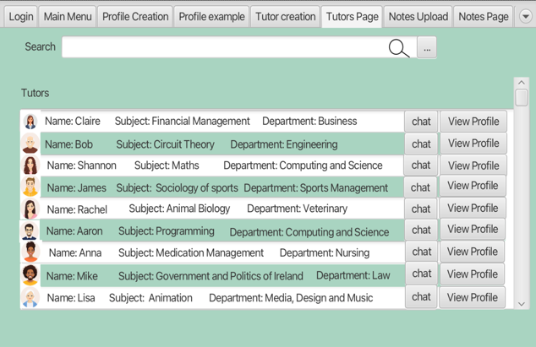Prototype is a basic model or sample product used to test and improve ideas before making the final version.

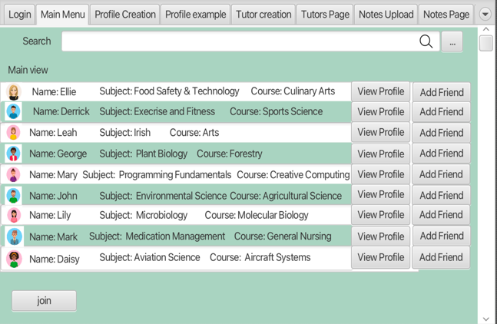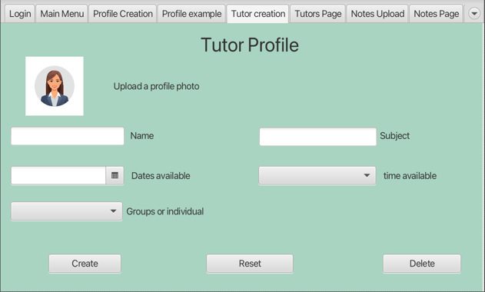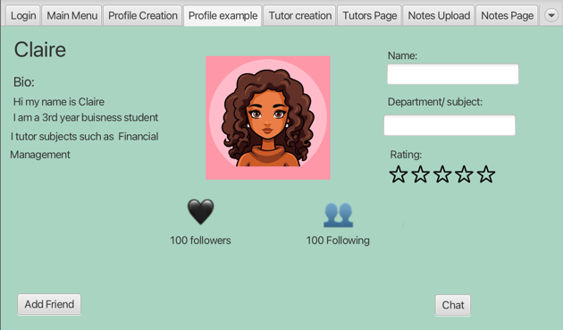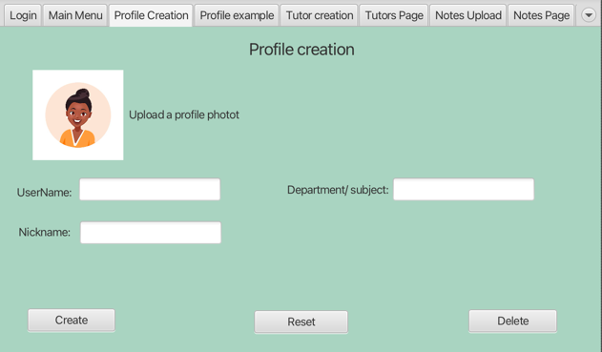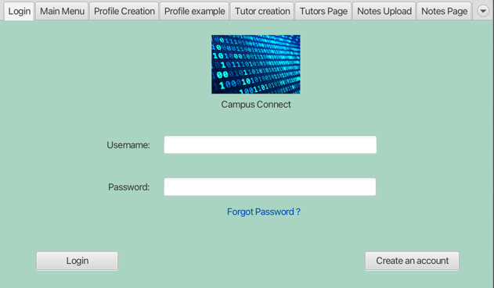

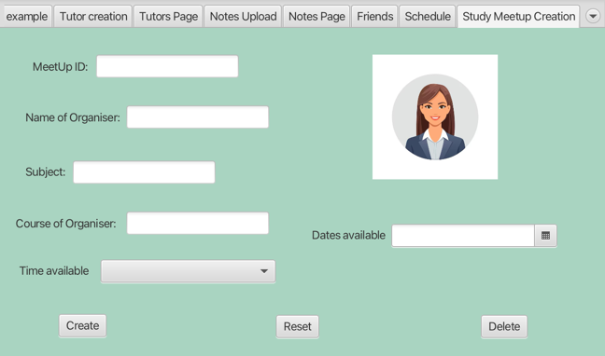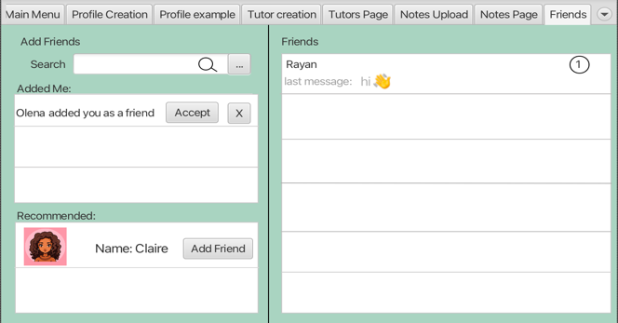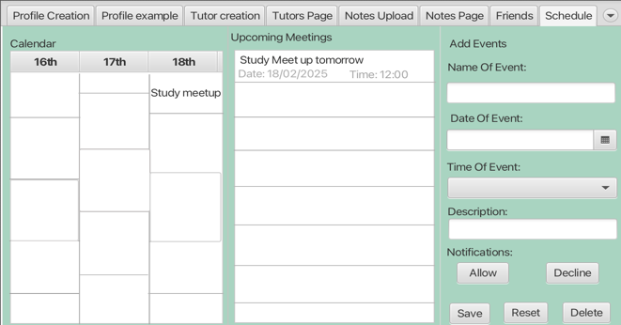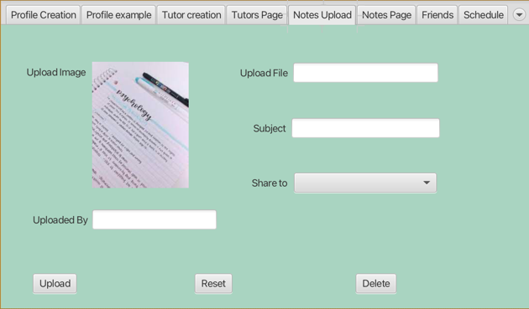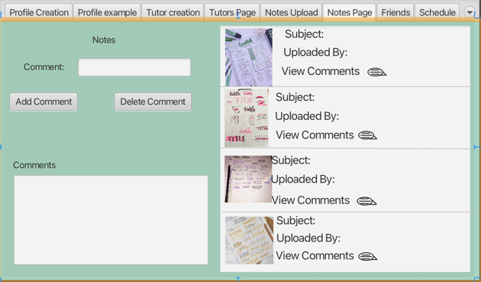

## Tool used to create Prototype (say if you found it easy to use or not briefly!!!)

I found SceneBuilder easy to use as I have used it in previous projects and so have experience with it and I quite enjoy using it as I enjoy designing.

## Diagrams

[Software-CA diagram: Lucidchart](https://lucid.app/lucidchart/732c04da-0516-4db3-84a7-3f19bc080ae3/edit?existing=1&docId=732c04da-0516-4db3-84a7-3f19bc080ae3&shared=true&invitationId=inv_a69515de-d180-469b-8553-21faaa53842e&page=0_0)

Use case description: Allows a user to create meetups from the list of available dates. Enables tutors and students to organize educational discussions, prepare for exams, or receive assistance with lab work.

Use Case Name: Meetup Creation and Participation

Actors:

* Tutor
* Student

Triggers:

* The user wants to create a meetup

Preconditions:

* A tutor creates a meetup
* A student asks for meetup

Post conditions:

* Students get help with exams or labs
* Tutor knows the week moments in the students’ knowledge

Normal Flow:

1. A tutor creates a meetup from the available list.
2. A tutor gives a title/subject of a meetup.
3. A tutor sends a notification to the group/main page.
4. A student receives a notification.
5. A day before all the members of the meetup receives the notification.
6. All the members of the meetup login.
7. All members of meetup can share notes/files/chat.

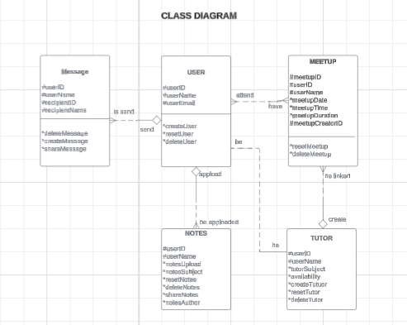

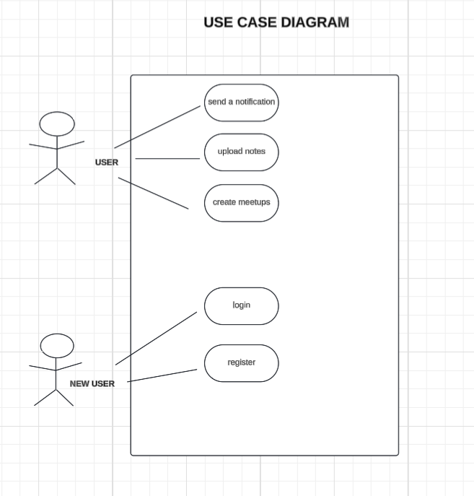

## Java



